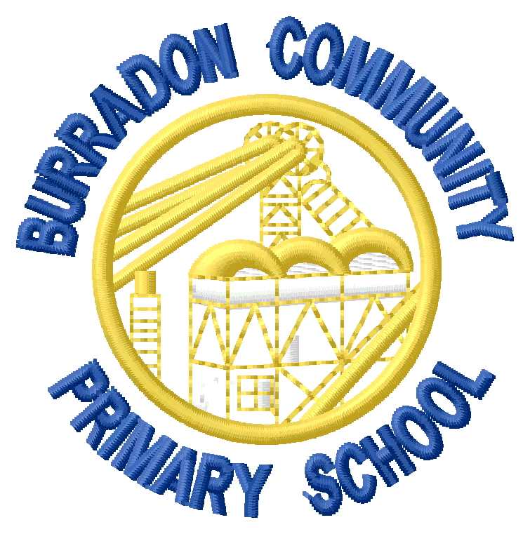

Burradon Community Primary School
Social Media Policy

Reviewed: February 2025

Review due: February 2026

Miss Watts

Burradon Community Primary School Social Media Policy

Rationale

The rationale of this policy is to explain acceptable use of social media relating to the Burradon Community Primary School social media account on Facebook (Burradon Community Primary School) for staff, children, parents and governors. The policy will therefore aim to explain the purpose of Facebook in Burradon Community Primary School and the benefits that will arise from its proper use, and also deal with any potential pitfalls.

What is Facebook?

Facebook is an online social networking site which enables users to communicate and share online content with other Facebook users. Facebook allows users to create ‘Pages’ which are for businesses, brands and organisations to share their stories and connect with people by creating ‘Posts’. Pages can be customised by publishing stories, hosting events, adding apps and more. Other Facebook users are able to ‘Visit’ and ‘Like’ the Page and they and their friends can get updates in their ‘News Feed’ to stay up to date with current events. The obvious benefit of having other users ‘Like’ the page is that the information you broadcast is instantly distributed into their news feed. Users can also private message each other when they don’t want conversations to appear. Burradon Community Primary School will allow private messages to be received via our Facebook page but this will be constantly monitored to ensure appropriate use.

Seesaw
Seesaw is an online journal where teachers can keep examples of learning. Your child’s class teacher will regularly post examples of learning onto your child’s account such as photographs and videos. When a teacher posts onto your child’s account you will receive a notification. You can then look at the work and have the option to ‘like’ it.
When a parent creates a Seesaw account they will then have access to their child’s journal so that this learning can be shared at home. This is through a child’s unique QR code from their class teacher. Once parents/carers have this they can simply download the Seesaw Class app onto a tablet, phone or other mobile device or access the seesaw.me website and follow the registration instructions.
Once registered, they will have access to their child’s account.

Primary Purpose of our Social Media

Burradon Community Primary School Page will be used principally to be followed by staff, parents and other professionals in order to promote positive events in school, form positive working relationships with other professionals and to celebrate the excellent work by staff, children, parents and governors. It will also contain information detailing special events in school. The aim of this is to run alongside more traditional methods like sending home letters, and not to replace it.

When using images of pupils or group images of pupils no names will be included unless permission has been given via parents for special circumstances. Parents will be asked to provide consent for their child’s image to be used in public arenas, namely Facebook, Seesaw, the School Website and by external agencies (see Computing Permissions for further information) at the start of their Burradon School career or in-year for pupils admitted during term time. On an annual basis, parents/carers will be asked to contact the school if there are changes to the consent form that they signed at the beginning of their child’s education at Burradon Community Primary School.

Guidance for publishing posts (Facebook):

- All staff are able to post from secure school devices but should follow the guidelines laid out below.
- Where possible photos should be group shots, pupil names will not be included in posts.
- Reporting on planned events should be made retrospectively wherever possible.
- Staff are encouraged to @ appropriate users and include appropriate hashtags (#) wherever possible to heighten promotion of the school when tweeting.
- Staff are encouraged to ‘tag’ appropriate users and include appropriate hashtags (#) wherever possible to heighten promotion of the school when publishing on Facebook.
- Facebook allows staff edit published posts, therefore if posts are deemed to include incorrect information they must be edited and posted again correctly.

Content Responsibility and Control

The uploading of content on the Burradon Community Primary School page is a shared responsibility for teaching staff across key stages. The Senior Leadership Team and Computing subject lead will be responsible for the general maintenance and monitoring of content and password protection.

Social Media Followers and Visitors

Anyone is able to follow or like the Burradon Community Primary School Page so long as they understand it is a ‘good news and information sharing’ tool. Burradon Community Primary School is a public page meaning that other users do not have to request to like and receive page updates. All social media users will be monitored on a regular basis by the Headteacher and Computing subject lead.

Facebook visitors may be blocked should school checks reveal any concerns of a safeguarding nature. Concerns could be:
- The quality of the biography of each individual as read in the bio section of their Facebook account.
- The images on view in the potential follower’s Facebook account.
- Language used in posts on an account.
- The school reserve the right to block an account for any other reason deemed appropriate in order to safeguard pupils, all other stakeholders and the school.

In most cases, one or more of the above will be enough to block an account. In the unlikely event that a parent, or other suitable user is incorrectly blocked, the Headteacher or SLT will hear each individual on a case-by-case basis. These hearings will usually involve the prospective user making themselves known in person to the above named persons, with their Facebook account details, and should take no more than a few minutes.

Inappropriate Content and Referencing

Burradon Community Primary School Page welcomes any referencing, mentions, interactions or visitor posts that show the school and pupils in a positive light only. Therefore, Burradon Community Primary School deems any of the following as inappropriate:
- Offensive language or remarks aimed at the school, its staff, pupils, parents, governors or others affiliated with the school.
- Unsuitable images or content posted into its feed.
- Unsuitable images or content finding its way from another’s account into the Burradon Community Primary School accounts.
- Comments that aim to undermine the school, its staff, pupils, parents, governors or others affiliated with the school.
- Using Burradon Community Primary School Page as a means of communication regarding individual pupils or queries about specific information.

Families wishing to enter into a discussion with the school should use the school number 0191 6434680, or the school email address info@burradoncommunityprimary.org.uk

Any inappropriate content will be deleted and its users will be removed, blocked, and, depending on the nature of the comment, reported to Twitter or Facebook. Furthermore, incidents of a more serious nature may be reported to the appropriate authority.

Responsible Use of Social Media

Governors of Burradon Community Primary School strongly request that visitors to Burradon Community Primary School Page DO NOT use images of other people’s children posted on the school social media accounts to repost on their own social networking sites or pages.

In accordance with GDPR 2018 (Data protection) please refer to the policy on our school website using the following hyperlink for information on how we collect, control, process and protect data.
Please note : we share some data with the Local Authority, DfE and outside agencies as defined by our policies.
http://www.burradoncommunityprimaryschool.co.uk/data-protection-gdpr/

