
Burradon Community Primary School

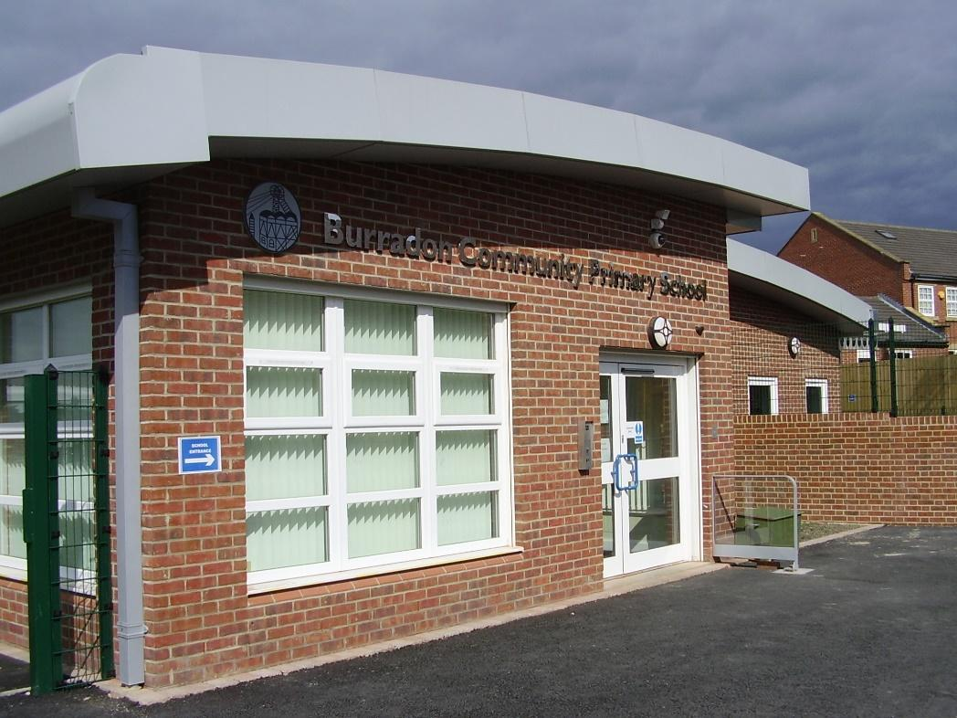

Computing Policy
February 2025

Miss Rachel Watts

Rationale

The use of computers and computer systems is an integral part of the National Curriculum and knowing how they work is a key life skill. In an increasingly digital world there now exists a wealth of software, tools and technologies that can be used to communicate, collaborate, express ideas and create digital content. ICT promotes initiative, independent and resilient learning, with pupils being able to make informed judgements about when and where to use Computing to its best effect. At Burradon Community Primary we recognise that pupils are entitled to a broad and balanced computing education with a structured, progressive, approach to the learning how computer systems work, the use of IT and the skills necessary to become digitally literate and participate fully in the modern world. We believe that our Computing curriculum prepares pupils to participate in a rapidly changing world in which they work and other activities are increasingly transformed by access to varied and developing technology. Our curriculum takes it aim from all of our core values, across Digital Literacy, Information Technology and Computer Science:

Learning together; growing together
Be curious about the world around you, ask questions and investigate.
Care and respect yourself, other people, our school and the wider world.
Persevere and be resilient - be the best you can.
Stay safe, make sensible choices and do things that make you happy.
At the heart of the community

Intent
Our Computing curriculum aims are to provide a broad, balanced, challenging and enjoyable curriculum for all pupils whilst meeting the requirements of the national curriculum programmes of study for Computing at Key Stage 1 and 2. Computing also aims to interlink between aspects of the EYFS framework. Computing has links with mathematics, science and design and technology with insights into both natural and artificial systems. Computer Science is the core of computing where children are taught the principles of information and computation, how digital systems work and how to put this knowledge to use through programming. The curriculum aims to develop pupil’s computational thinking skills that will benefit them throughout their lives. This includes equipping pupils with the confidence and skills to use digital tools and technologies throughout their lives; developing the understanding of how to use computers and digital tools safely and responsibly and responding to new developments in technology. Computing at Burradon also aims to enhance and enrich learning in other areas of the curriculum using IT and computing.

The school believes that Information Technology, Computer Science and Digital Literacy:

- Are essential life skills necessary to fully participate in the modern digital world.
- Allow children to become creators of digital content rather than simply consumers of it.
- Provide access to a rich and varied source of information and content.
- Communicate and present information in new ways, which helps pupils understand, access and use it more readily.
- Can motivate and enthuse pupils.
- Encourage problem solving and resilience.
- Offer opportunities for communication and collaboration through group working both inside and outside of school.
- Have the flexibility to meet the individual needs and abilities of each pupil.

The National Curriculum for Computing aims to ensure that all pupils:

- Can understand and apply the fundamental principles of computer science, including logic, algorithms, data representation, and communication.
- Can analyse problems in computational terms, and have repeated practical experience of writing computer programs in order to solve such problems.
- Can evaluate and apply information technology, including new or unfamiliar technologies, analytically to solve problems.
- Are responsible, competent, confident and creative users of information and communication technology.

Objectives

Early Years
It is important in the Early Years Foundation Stage to give children a broad, play-based experience of Information Technology and computing in a range of contexts, including outdoor play. Computing is not just about computers. Early Years Foundation Stage learning environments should feature Information Technology scenarios based on experience in the real world, such as in role play and simple categorisation. Children gain confidence, control and language skills through opportunities such as ‘programming’ each other using directional language to find toys/objects, creating artwork using digital drawing tools and controlling programmable toys. Outdoor exploration is an important aspect and using digital recording devices such as video recorders, cameras and microphones can support children in developing communication skills. This is particularly beneficial for children who have English as an additional language.

By the end of Key Stage 1 pupils should be taught to:
- Understand what algorithms are, how they are implemented as programs on digital devices, and that programs execute by following a sequence of instructions.
- Write, test and debug simple programs.
- Use logical reasoning to predict and computing the behaviour of simple programs.
- Organise, store, manipulate and retrieve data in a range of digital formats.
- Communicate safely and respectfully online, keeping personal information private, and recognise common uses of information technology beyond school.

By the end of key stage 2 pupils should be taught to:
- Design, write and debug programs that accomplish specific goals, including controlling or simulating physical systems; solve problems by decomposing them into smaller parts.
- Use sequence, selection, and repetition in programs; work with variables and various forms of input and output; generate appropriate inputs and predicted outputs to test programs.
- Use logical reasoning to explain how a simple algorithm works and to detect and correct errors in algorithms and programs.
- Understand computer networks including the internet; how they can provide multiple services, such as the world-wide web; and the opportunities they offer for communication and collaboration.
- Describe how internet search engines find and store data; use search engines effectively; be discerning in evaluating digital content; respect individuals and intellectual property; use technology responsibly, securely and safely.
- Select, use and combine a variety of software (including internet services) on a range of digital devices to accomplish given goals, including collecting, analysing, evaluating and presenting data and information.

Implementation

At Burradon Community Primary School Computing is taught as a discrete lesson and is used as an effective teaching tool across all areas of the curriculum. This ensures children are able to develop depth in their knowledge and skills over the duration of each of their computing topics. The principle aim is to develop children’s knowledge, skills, confidence and understanding in relation to Information Technology, Computer Science and Digital Literacy. We follow the NCCE’s (National Centre for Computing Education) Teach Computing scheme for work using their cyclical pedagogy to ensure our pupils know more, remember more and are able to do more with their computing knowledge and skills.

A variety of teaching methods are employed to enable children to experience working as an individual, in pairs, in groups and as a whole class. Children will engage in practical computing lessons using a variety of software and equipment designed to engage learners and to enhance and develop computing skills and knowledge. We have Chromebooks, computers, iPads and CleverTouch boards to ensure that all year groups have the opportunity to use a range of devices and programs for many purposes across the wider curriculum.

Where possible, employing cross-curricular links motivates pupils and supports them to make connections and remember the steps they have been taught. Our curriculum also ensures a balanced coverage of computer science, information technology and digital literacy. The children will have experiences of all three strands in each year group, but the subject knowledge imparted becomes increasingly specific and in depth, with more complex skills being taught, thus ensuring that learning is scaffolded and all National Curriculum requirements are covered.

At Burradon, the three strands of Computing are taught around a set of key concepts. A range of key concepts are explored through each computing unit.
These concepts include:
1. Computing systems and networks: (systems, networks and how they are used, the internet, hardware and software)
2. Programming: (interpreting, creating and evaluating algorithms, programming to accomplish specific goals, detecting and correcting errors)
3. Data and information: (collecting, analysing, evaluating, presenting data and information)
4. Creating media: (design and development, communicating and collaborating online, evaluating online content, respectful and responsible communication, presenting, creating content)

E-Safety
Internet safety is taken extremely seriously and is embedded within our curriculum. We have an E-Safety Policy that provides guidance for teachers and children about how to use the internet safely. Each year group participates in lessons on E-Safety using Project Evolve which includes area of the RSE curriculum. Children understand how to stay safe when using technology and E-Safety House events and half termly assemblies are held regularly to address current issues.

Filtering and Monitoring
Burradon Community Primary schools provides a safe environment to learn and work, including when online. Filtering and monitoring are both important parts of safeguarding pupils and staff from potentially harmful and inappropriate online material. Our filtering and monitoring systems are regularly reviewed

As a school, our filtering and monitoring is provided by North Tyneside Council (NTC) Network. This includes web filtering for students and teachers, as well as, security and firewall management.
The Designated Safeguarding Lead holds responsibility for responsibility for safeguarding and online safety, which could include overseeing and acting on:
- filtering and monitoring reports
- safeguarding concerns
- checks to filtering and monitoring systems
North Tyneside Council hold technical responsibility for:
- maintaining filtering and monitoring systems
- providing filtering and monitoring reports
- completing actions following concerns or checks to systems

Meeting digital and technology standards in schools
7.1/ You should identify and assign roles and responsibilities to manage your filtering and monitoring systems
- DSL: Angela Hunter
- IT Provider: North Tyneside Council
- IT Technician: NT Council Technicians
- Filtering and monitoring system: Smoothwall
7.2/ You should review your filtering and monitoring provision at least annually
- Review of filtering and monitoring by DSL, Computing Lead NT Council provider twice yearly.
7.3/ Your filtering system should block harmful and inappropriate content, without unreasonably impacting teaching and learning
- See weekly Smoothwall filtering reports
7.4/ You should have effective monitoring strategies that meet the safeguarding needs of your school or college
- See Smoothwall monitoring log and device (inappropriate and blocked sites) report
- In school monitoring log also used
7.5/ 360 Review
- See review completed January 2026
7.6/ Filter Test Result
- See weekly filtering test log. Reports sent from North Tyneside if inappropriate content is flagged.

See Filtering and Monitoring checklists

Adaptation

At Burradon Community Primary School all children matter and are given every opportunity to achieve their potential. There are those children who have particular teaching and learning requirements which go beyond the provision for that age range and if not addressed, could create barriers to learning. This could include more able children, those with SEN or those who have EAL. Teachers must take account of these requirements and plan, where necessary, to support individuals or groups of pupils to enable them to participate effectively in the curriculum and assessment activities. During any teaching activities, teachers should bear in mind that special arrangements could be made available to support individual pupils. This is in accordance with the school inclusion policy. These children should be identified and discussed at pupil progress meetings to ensure that appropriate provisions and/or interventions are effected.

Equal Opportunities in Computing

We will ensure that all children are provided with the same learning opportunities regardless of social class, gender, culture, race, disability or learning difficulties. As a result, we hope to enable all children to develop positive attitudes towards others. All pupils have equal access to computing and all staff members follow the equal opportunities policy. Resources for SEN children and gifted & talented will be made available to support and challenge appropriately.

Cross Curricular Links

As a staff we are all aware that IT and computing skills should be developed through core and foundation subjects. Where appropriate, IT and computing should be incorporated into work for all subjects. IT and computing should be used to support learning in other subjects as well as developing computing knowledge, skills and understanding.

Impact

Our Computing curriculum is well thought out, well resourced and is planned to demonstrate progression and prepare children for their life ICT journey. Furthermore, we measure the impact of our curriculum through the following methods:
- A reflection on standards achieved against the planned outcomes, completed half termly by teachers
- Children can understand and apply the fundamental principles and concepts of computer science, including abstraction, logic, algorithms and data representation;
- Children can evaluate and apply information technology to solve problems;
- Children are responsible, competent, confident and creative users of information and communication technology and digital literacy.

Teachers regularly assess progress through observations and evidence. In the Foundation Stage the children are assessed within the strands of the Early Years Framework. In Key Stage 1 and 2 key objectives to be assessed are taken from the National Curriculum to assess computing each term. To ensure that teaching is progressive across school, a ‘Progression of Skills’ document breaks down the skills needed to achieve in each strand of the computing curriculum from EYFS to Year 6. This ensures that each member of staff in each year group has clear expectations of what objectives need to be covered but also what skills should also be taught. This will also ensure that the children are being taught Computing which is matched carefully to the needs of the curriculum but also to the needs of the children.

Assessing computing is an integral part of teaching & learning and key to good practice. Assessment should be process orientated - reviewing the way that techniques and skills are applied purposefully by pupils to demonstrate their understanding of computing concepts. As assessment is part of the learning process, it is essential that pupils are closely involved. Assessment can be broken down into:

- Formative assessments are carried out during and following short focused tasks and activities. They provide pupils and teaching staff the opportunity to reflect on their learning in the context of the agreed success criteria. This feeds into planning for the next lesson or activity.
- Summative assessment should review pupils' ability and provide a best fit ‘level’. Independent tasks provide a number of opportunities and scope for pupils to demonstrate their capability throughout the term. There should be an opportunity for pupil review and identification of next steps. Summative assessment should be recorded for all pupils – showing whether the pupils have met, exceeded or not achieved the learning objectives.

We assess the children’s work in computing by making informal judgments as we observe the children during lessons. Each term we make a summary judgment of the work for each pupil as to whether they are working towards, expected or achieving greater depth in the particular curriculum objectives which have been covered that term. The computing assessment document provides staff with a breakdown of skills statements showing what would be expected at each level, working towards, expected or greater depth, for each strand of the computing curriculum. This is used in conjunction with Computing Progression of Skills document. Both of which ensure that staff can make accurate judgements based on the skills the children show in their computing lessons and on those they can transfer to use in other areas of the curriculum.

Assessment is recorded termly and we use these to plan future work, provide the basis for progress and to communicate with the pupil’s future class teacher(s) and computing lead. The children’s work is saved on the school network. Other work may be printed and filed within the subject from which the task was set. The Seesaw app can also be used to keep an e-portfolio of evidence.

Monitoring and Evaluation

The subject leader is responsible for monitoring the standard of the children’s work and the quality of teaching in line with the schools monitoring cycle. This may be through lesson observations, pupil discussion and evaluating pupil work.
We allocate time for the vital task of reviewing samples of children’s work and for visiting classes to observe teaching in the subject. We also complete work scrutinies and data overviews on a termly basis which enables the subject leader to compile a whole school overview of the attainment in computing and identify next steps to ensure continued progress across the school.

The Role of the Subject Leader

The computing subject leader (Miss Rachel Watts) is responsible for the implementation of computing policy across the school. Her role is to:

- Co-ordinate the development of a long term plan for computing across the school.
- Review the Computing and Social Media policies on an annual basis and update as required.
- Offer help and support to all members of staff in their teaching, planning and assessment of computing.
- Provide colleagues opportunities to observe good practice in the teaching of computing.
- Maintain resources and advise staff on the use of digital tools, technologies and resources.
- Monitor classroom teaching or planning following the schools monitoring programme.
- Monitor the children’s progression in computing, looking at examples of work of different abilities.
- Manage the computing budget.
- Keep up-to-date with new technological developments and communicate information and developments with colleagues.
- Lead staff training on new initiatives.
- Attend appropriate in-service training.
- Have enthusiasm for computing and encourage staff to share this enthusiasm.
- Keep parents and governors informed on the implementation of computing in the school.
- Help staff to use assessment to inform future planning.
- Regularly update and maintain computing permissions and agreements.
- Manage the e-portfolio used in school (Seesaw) and regularly review parental engagement.
- Promote the use of Facebook to showcase school events and activities.

The Role of the Class Teacher

Individual teachers will be responsible for ensuring that pupils in their classes have opportunities for learning computing and using their knowledge, skills and understanding of computing across the curriculum or Early Years Foundation Stage.

They will plan and deliver the requirements of the National Curriculum for Computing to the best of their ability. We set high expectations for our pupils and provide opportunities for all to achieve, including girls and boys, pupils with educational special needs, pupils with disabilities pupils from all social and cultural backgrounds, and those from diverse linguistic backgrounds.
The class teacher’s role is a vital role in the development of computing throughout the school and will ensure continued progression in learning and understanding, and create effective learning environments.

The class teacher will also:

- Secure pupil motivation and engagement.
- Provide equality of opportunity using a range of teaching approaches and techniques.
- Use appropriate assessment techniques and approaches.
- Maintain up to date assessment records (see policy document).

Staff Training

The computing subject leader will assess and address staff training needs as part of the annual development plan process or in response to individual needs and requests throughout the year.

Individual teachers should attempt to continually develop their own skills and knowledge, identify their own needs and notify the subject leader.

Teachers will be encouraged to use IT and computing to produce plans, reports, communications and teaching resources.

Resources and Access

Burradon Community Primary school acknowledges the need to continually maintain, update and develop its resources and to make progress towards consistent, compatible computer systems by investing in resources that will effectively deliver the objectives of the National Curriculum and support the use of IT, Computer Science and Digital Literacy across the school. Teachers are required to inform the computing subject leader of any faults as soon as they are noticed. Resources, if not classroom based, are located in the computing suite. A service level agreement with North Tyneside Council is currently in place to help support the subject leader to fulfill this role both in hardware & software. An annual subscription to Lightspeed is currently in place to support the computing subject lead to maintain the mobile device management in school i.e. iPads. Computing network infrastructure and equipment has been sited so that:

- Every classroom from Foundation Stage to Year 6 has a computer connected to the school network and an interactive whiteboard with sound and DVD facilities.
- The majority of staff have a staff iPad (all teachers and some TAs)
- There is computing suite of 30 desktops and 30 iPads.
- There are also 4-5 iPads in each classroom for daily use.
- There are 60 Chromebooks in school.
- There are 2 iPad Sync & Charge cabinets in school.
- There are 15 Lego WeDo kits, 5 Spike Prime Lego kits, 6 Spike Essential Kits and 5 Lego Discover bags. .
- There are 18 Raspberry Pi kits in school.
- In the EYFS there is a box of technological resources such as remote control cars, talk tins and walkie talkies.
- There is a range of additional resources such as Beebots, Tuff Cams and Data Logger kits stored in the ICT suite.
- Internet access is available in all classrooms.
- Each class has 1 allocated slot in the ICT suite per week for teaching computing as a discrete subject.
- The computing suite and iPads are available for use throughout the school day as part of computing lessons and for cross-curricular use.
- Pupils may use IT and computing independently, in pairs, alongside a TA or in a group with a teacher.
- The school has a computing technician who can be contacted as and when issues arise.
- A governor will be invited to take a particular interest in computing in the school.

Security (see also E-Safety policy)

We take security very seriously. As such:
- The computing technician will be responsible for updating anti-virus software on an annual basis.
- Use of IT and computing will be in line with the school’s ‘Acceptable Use Policy’. All staff, volunteers and children must sign a copy of the schools AUP.
- Parents will be made aware of the ‘Acceptable Use Policy’ at school entry.
- All pupils and parents will be aware of the school rules for responsible use of IT and computing and the internet and will understand the consequence of any misuse.
- All pupils must have a signed computing agreement in order to access the internet. Parents must also agree to the use of their child’s photographs, work and videos on Seesaw, Social Media, the school website and by external agencies. This permission is updated annually.
- The agreed rules for safe and responsible use of IT and computing and the internet will be displayed in all computing areas.

Parental Involvement

Parents are encouraged to support the implementation of IT and computing where possible by encouraging use of IT and computing skills at home for pleasure, through home-learning tasks and use of the school website. Parents will be made aware of issues surrounding e-safety and encouraged to promote this at home. Parents are kept up to date with school activities through the use of Seesaw, an app which allows teachers to create an e-portfolio of photographs and videos to demonstrate a range of learning which is taking place in school. Parents are also encouraged to like our Facebook Page, Burradon Community Primary School, and are welcome to mention or reference any interactions which show the school in a positive light (see Social Media Policy for further information).

Review date: February 2026
This policy should be read in conjunction with other policies including – E-safety, Social Media, Acceptable Use Policy, Child Protection and Safeguarding.

In accordance with GDPR 2018 (Data protection) please refer to the policy on our school website using the following hyperlink for information on how we collect, control, process and protect data.
Please note : we share some data with the Local Authority, DfE and outside agencies as defined by our policies.
http://www.burradoncommunityprimaryschool.co.uk/data-protection-gdpr/

