Mathematics

Number:
• Count reliably to 100.
•Count forwards and backwards in 1s, 2s, 5s and 10s
• Write all numbers in words to 20.
•Say the number that is one more or one less than a
number to 100.
•Recall all pairs of addition and subtraction number
bonds to 20.
• Add and subtract 1-digit and 2-digit numbers to 20,
including zero.
• Know the signs + - =.
• Solve a missing number problem.
•Solve a one-step problem using addition
and subtraction, using concrete objects and
pictorial representations.

Measurement and Geometry:
• Recognise all coins.
• Recognise and name the 2D shapes: circle, triangle, square and rectangle.
• Recognise and name the 3D shapes: cuboid, pyramid, sphere.
• Name the days of the week and months of the year.
• Tell the time to o’clock and half past the hour.

Burradon Community Primary School

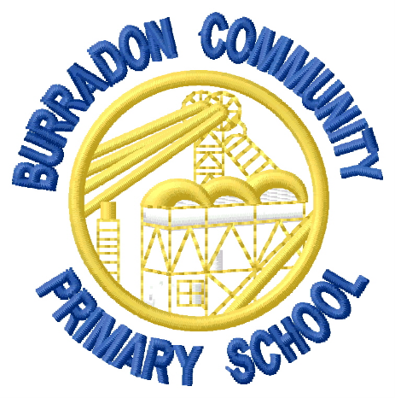

End of Year Expectations:
Year 1

This booklet provides information for parents/carers on the end of year expectations for children in our school. The National Curriculum outlines these expectations as being the minimum requirements your child should meet each year.
All of the objectives will be focused on throughout the year as part of your child’s lessons. Any extra support you can provide in helping your child to achieve these expectations is greatly valued.
If you have any queries regarding these expectations or would like support in knowing how to help your child with these, please see the class teacher.

