Mathematics

Number
• Recall all multiplication facts to 12 x 12.
• Round any number to the nearest 10, 100 or 1000 and decimals with one decimal place to the nearest whole number.
• Count backwards through zero to include negative numbers.
• Compare numbers with the same number of decimal
places up to 2-decimal places.
• Recognise and write decimal equivalents of any number of tenths or hundredths.
• Add and subtract with up to 4-decimal places using formal written methods of columnar addition and
subtraction.
• Divide a 1 or 2-digit number by 10 or 100 identifying the value of the digits in the answer as units, tenths and hundredths.
• Multiply 2-digit and 3-digit numbers by a 1-digit number using formal written layout.
• Solve two step addition and subtraction problems in context.
• Solve problems involving multiplication.

Measurement and Geometry:
•Compare and classify geometrical shapes, including quadrilaterals and triangles, based on their properties and sizes.
• Know that angles are measured in degrees and identify acute and obtuse angles.
• Compare and order angles up to two right angles by
size.
• Measure and calculate the perimeter of a rectilinear figure in cm and m.
• Read, write and convert between analogue and digital
12 and 24 hour times.
• Interpret and present discrete and continuous data using appropriate graphical methods, including bar charts and time graphs.

Burradon Community Primary School

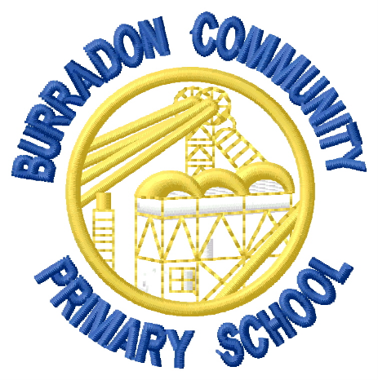

End of Year Expectations:
Year 4

This booklet provides information for parents/carers on the end of year expectations for children in our school. The National Curriculum outlines these expectations as being the minimum requirements your child should meet each year.
All of the objectives will be focused on throughout the year as part of your child’s lessons. Any extra support you can provide in helping your child to achieve these expectations is greatly valued.
If you have any queries regarding these expectations or would like support in knowing how to help your child with these, please see the class teacher.

