Mathematics

Number
• Count forwards and backwards in steps of powers of 10 for any given number up to 1,000,000.
• Recognise and use thousandths and relate them to tenths, hundredths and decimal equivalents.
• Recognise mixed numbers and improper fractions and convert from one to the other.
• Read and write decimal numbers as fractions.
• Recognise the % symbol and understand percent relates to a number of parts per hundred.
• Write percentages as a fraction with denominator hundred and as a decimal fraction.
• Compare and add fractions whose denominators are all multiples of the same number.
• Multiply and divide numbers mentally drawing on known facts up to 12 x 12.
• Round decimals with 2dp to the nearest whole number and to
1dp.
• Recognise and use square numbers and cube numbers; and use the notation 2 and 3.
• Multiply and divide whole numbers and those involving
decimals by 10, 100 and 1000.
• Multiply numbers up to 4-digit by a 1 or 2-digit number using formal written methods, including long multiplication for a 2-digit number.
• Divide numbers up to 4-digits by a 1-digit number.
• Solve problems involving multiplication and division where large numbers are used by decomposing them into factors.
• Solve addition and subtraction multi-step problems in context, deciding which operations and methods to use and why.
• Solve problems involving numbers up to 3dp.

Measurement and Geometry:
• Know that angles are measured in degrees.
• Estimate and compare acute, obtuse and reflex angles.
• Draw given angles and measure them in degrees.
• Convert between different units of metric measures and estimate volume and capacity.
• Measure and calculate the perimeter of composite rectilinear shapes in cm and m.
• Calculate and compare the areas of squares and rectangles
including using standards units (cm2 and m2).
• Solve comparison, sum and difference problems using information presented in a line graph.
Burradon Community Primary School

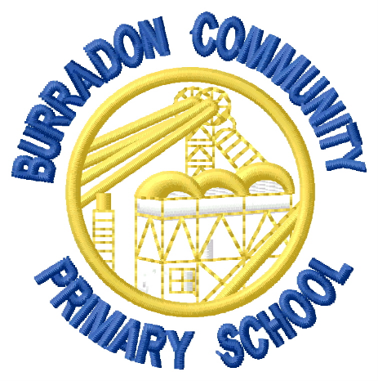

End of Year Expectations:
Year 5

This booklet provides information for parents/carers on the end of year expectations for children in our school. The National Curriculum outlines these expectations as being the minimum requirements your child should meet each year.
All of the objectives will be focused on throughout the year as part of your child’s lessons. Any extra support you can provide in helping your child to achieve these expectations is greatly valued.
If you have any queries regarding these expectations or would like support in knowing how to help your child with these, please see the class teacher.

