
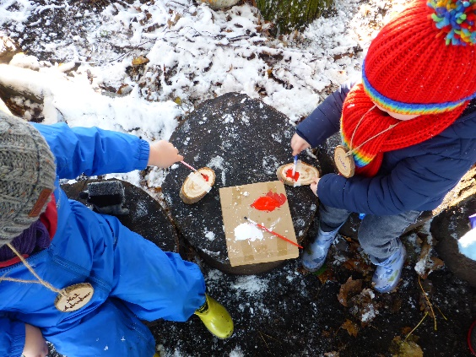
Computing

- E-Safety
- Creating Media – Digital painting
Children will develop their understanding of a range of tools used for digital painting. They then use these tools to create their own digital paintings, while gaining inspiration from a range of artists’ work. The unit concludes with learners considering their preferences when painting with and without the use of digital devices.
PE
- Multi Skills:
- ABC
- Ball Skills
and
- Gymnastics

Music
Charanga
- -Weekly Rhythm grid (freestyle –creative apps)
- -Rhythm in the way we walk

- Singing strategy
- Rhythm in the way we walk
- Banana rap
- Nativity songs

Nk RE- Christianity
Christmas: How and why is Christmas celebrated by Christians?
Why are gifts given at Christmas?

Art and Design
Crafting!
Year 1 will be weaving, wefting and exploring thread.

The unit will culminate in creating some fabulous fibre art.
History

We will learn about the differences and similarities in the lives of Florence Nightingale, Mary Seacole and Edith Cavell.
We will have an understanding of the chronology of the historical periods in which Florence Nightingale, Mary Seacole and Edith Cavell lived.
We will be able to recall some key facts about the experiences of Florence Nightingale, Mary Seacole and Edith Cavell.

PSHCE
- Emergency Services
- Being Happy
- First Aid/CPR
- What makes a family?
- Anti-Bullying charter and activities for Anti-Bullying Week.

Science
- To identify and name a variety of common wild and garden plants, including deciduous and evergreen trees by exploring the woodland area.
- To identify and describe the basic structure of a variety of common flowering plants, including trees.
- Observe changes across the 4 seasons
- To observe and describe weather associated with the seasons and how day length varies.

The Great Outdoors
Year 1
Autumn Term (2)

