Mathematics
Number
• Use negative numbers in context, and calculate intervals across zero.
• Round any whole number to a required degree of accuracy and solve problems which require answers to be rounded.
• Solve problems involving the relative sizes of two quantities where the missing values can be found by using integer multiplication and division facts.
• Use common factors to simplify fractions.
• Solve problems involving the calculation of percentages.
• Multiply 1-digit numbers with up to two decimal places by whole numbers.
• Perform mental calculations, including with mixed operations.
• Divide numbers up to 4-digits by a 2-digit whole number using formal written methods of long division and interpret remainder in various ways.
• Use knowledge of ordering operations to carry out calculations involving all four operations.
• Add and subtract fractions with different denominators and mixed numbers, using the concept of equivalent fractions.
• Multiply simple pairs of proper fractions, writing the answer in its simplest
form.
• Divide proper fractions by whole numbers.
• Associate a fraction with division and calculate decimal fraction equivalents.
• Express missing number problems algebraically.
• Find pairs of numbers that satisfy number sentences involving two unknowns.
Measurement and Geometry:
• Recognise, describe and build simple 3D shapes, including their nets.
• Compare and classify geometric shapes based on their properties and sizes and find unknown angles in any triangle, quadrilateral and regular polygons.
• Illustrate and name parts of circles, including radius, diameter and circumference and know that the radius is half the diameter.
• Read, write and convert between standard units, converting measurements of length, mass, volume and time from a smaller unit of measure to a larger unit, and visa versa, using decimal notation to up to 3 decimal places.
• Calculate the area of a parallelogram and triangles and calculate, estimate and compare volume of cubes and cuboids using standard units.
• Interpret and construct pie charts and line graphs and use these to solve problems.
Burradon Community Primary School

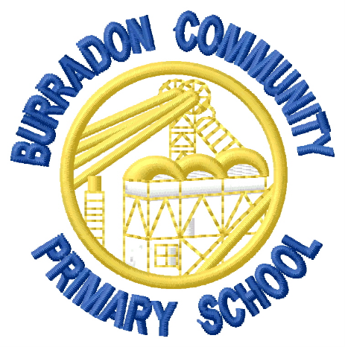

End of Year Expectations:
Year 6

This booklet provides information for parents/carers on the end of year expectations for children in our school. The National Curriculum outlines these expectations as being the minimum requirements your child should meet each year.
All of the objectives will be focused on throughout the year as part of your child’s lessons. Any extra support you can provide in helping your child to achieve these expectations is greatly valued.
If you have any queries regarding these expectations or would like support in knowing how to help your child with these, please see the class teacher.

