Music

Music and Me (Continued)
Children will:
- describe the style indicators of the song/music.
- describe the structure of the song.
- identify the instruments/voices they can hear.
- talk about the musical dimensions used in the song
- take part in workshop sessions.
- learn to clap some of the rhythms used in the song.
- learn some musical phrases that you will sing in the song
RE
What do we now know about Christianity? (exploration through the concepts)
Children will explore:
- Authority
- Expressions of belief
- Impact of belief

Science
Electricity
Children will:
- associate the brightness of a lamp or the volume of a buzzer with the number and voltage of cells used in the circuit
- compare and give reasons for variations in how components function, including the brightness of bulbs, the loudness of buzzers and the on/off position of switches
- use recognised symbols when representing a simple circuit in a diagram

Computing

3D Modelling
Children will:
- develop their knowledge and understanding
of using a computer to produce 3D models.
- familiarise themselves with working in a 3D
space, moving, resizing, and duplicating
objects.
- create hollow objects using placeholders
and combine multiple objects to create a
model of a desk tidy.
- examine the benefits of grouping and
ungrouping 3D objects, then go on to plan,
develop, and evaluate their own 3D model of
a building.

PE
Athletics
Children will:
- improve sprinting technique.
- understand and practise javelin and shot put technique
- understand and practise the sequence for triple jump
- practise long jump technique
- watch and describe specific aspects of running,
jumping and throwing styles.
- describe specific aspects of running, jumping and
throwing styles.
Outdoor and Adventurous Activities
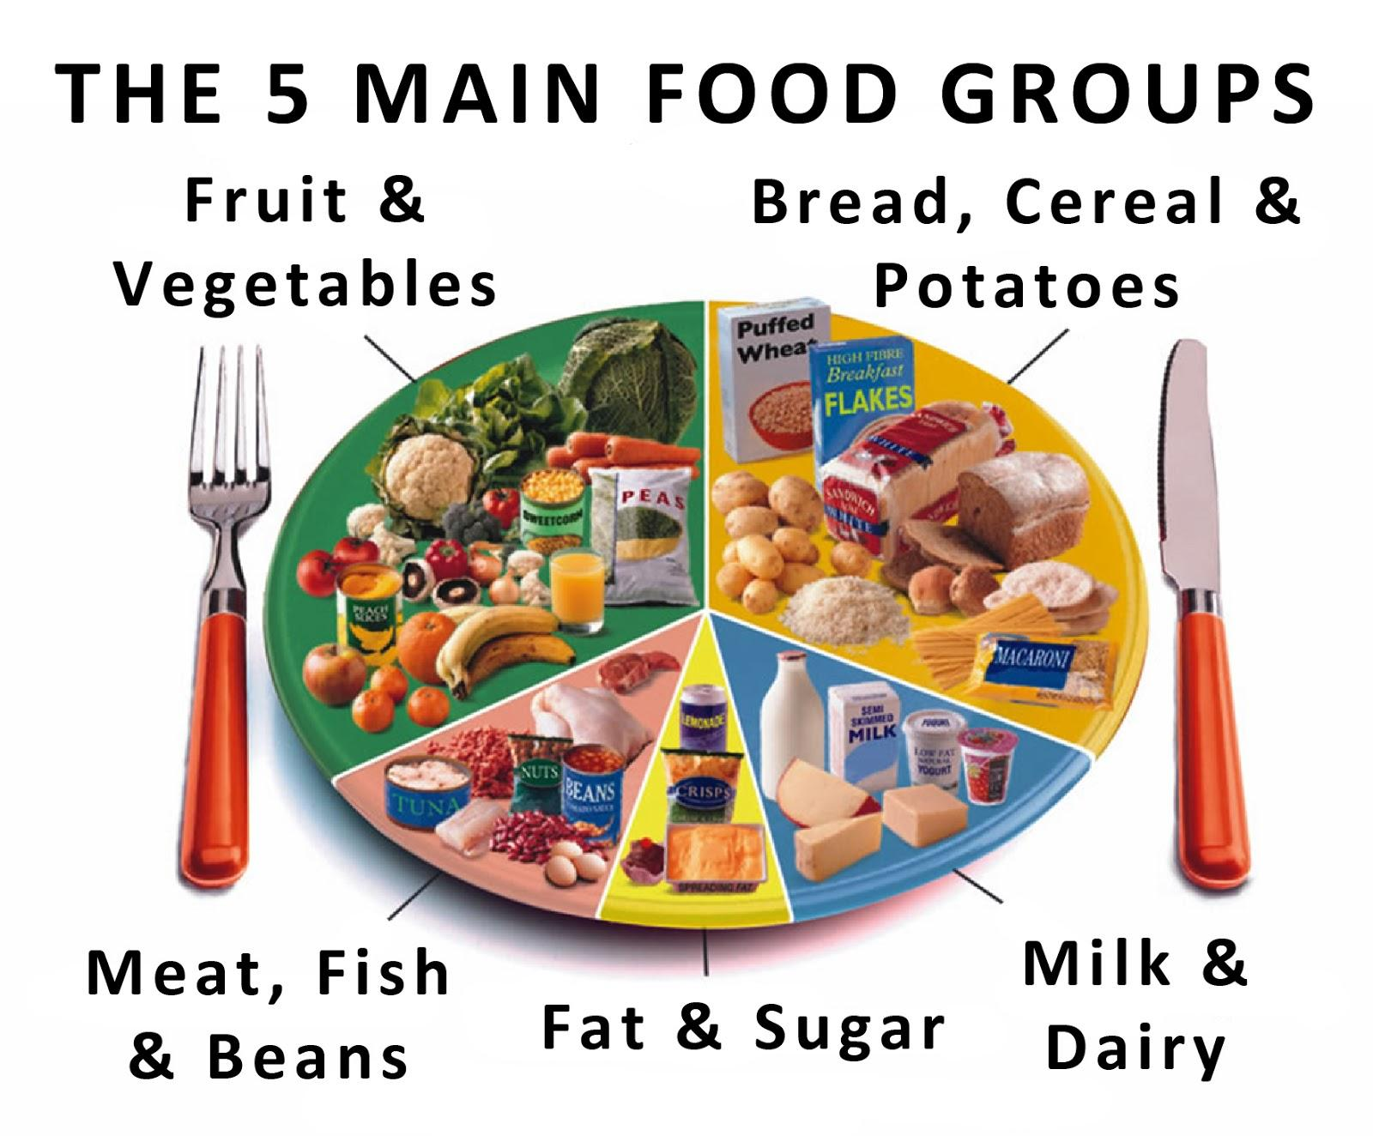
Summer 2 2025

French
J’habite (I live)
Children will:
-learn new topic vocabulary and practise using this
- Read and write short texts in the target language
- Ask and answer questions in French / take part in
role-play


Geography

Fair Trade
Children will:
- discuss what Fairtrade is.
- explain why someone should buy Fairtrade products.
- know why fair trade products are 'a good buy’ and how they help some of the poorest people in the world.
- persuasive language to encourage people to buy fair trade products
- be able to talk about fair trade projects in my country
- know where some of the energy used in my home comes from
- understand how energy is wasted at home and at school
- explain why we need to save energy
- discuss open ended questions linked to the unfair distribution of water

DT

Food: Culture and seasonality
Children will:
- Understand the main food groups and the different nutrients that are
important for health
- Understand what makes a healthy and balanced diet, and that different
foods and drinks provide different substances the body needs to be
healthy and active
- Understand how a variety of ingredients are grown, reared, caught and
processed to make them safe and palatable / tasty to eat
- Use his/her research into existing products and his/her market
research to inform the design of his/her own innovative product
- Make detailed evaluations about existing products and his/her own
considering the views of others to improve his/her work

PSHE

- Relationships and Sex Education Talks

- British Values - Rights and Radicalisation
- Feeling Anxious
- Recognising and Controlling Anger
- Ageism
- Transition
- Fair Trade

