Science
Working Scientifically
Investigating Materials, plants and the weather

Asking simple questions and recognising that they can be answered in different ways
- Observing closely, using simple equipment
- Performing simple tests
- Identifying and classifying
- Using their observations and ideas to suggest answers to questions
- Gathering and recording data to help in answering questions.

Music

Charanga
-Weekly Rhythm grid where we learn all about pulse, rhythm and beats (freestyle –creative apps)
- Leaning the song ‘ Round and Round’
- Beginning to use some musical instruments linked to the above song.

Physical Education
Athletics, Striking and Fielding
- Children to master basic movements including running, jumping, throwing and catching, as well as developing balance, agility and co-ordination, and begin to apply these in a range of activities.

-We will continue to complete the daily mile and utilise our outdoor area for lots of activity in lessons.

PSCHE
Signaling &
Sign Language

Wildlife

Food Safety & What Not to Eat

Braving the Weather

Balance of Good Health

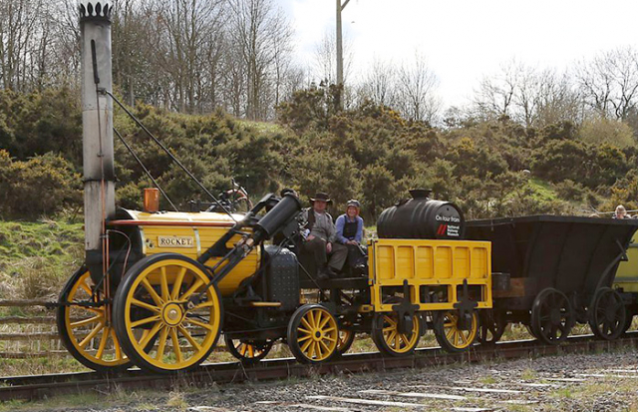
George Stephenson
Year 1
Summer 2
Religious Education
We are continuing to learn about Buddhism this half term.
Computing

- Creating Digital Media
- E- Safety

Art and Design and Technology
We are going to Design, make and evaluate our own vehicle…just like George Stephenson!
We will learn about wheels and axles and build our own vehicle that is able to transport cargo from one place to another.

Woven Wonders
We will be using skills to weave and create art out of fabric and paper.

History
Historical enquiry into George Stephenson
- Chronology and Vocabulary
- Using chronological vocabulary with a timeline
- Who was George Stephenson?
- What was Killingworth Billy?
- Changes in railways and trains
- Debate! Stephenson’s impact locally and nationally Enquiry – Was George Stephenson all that significant?

