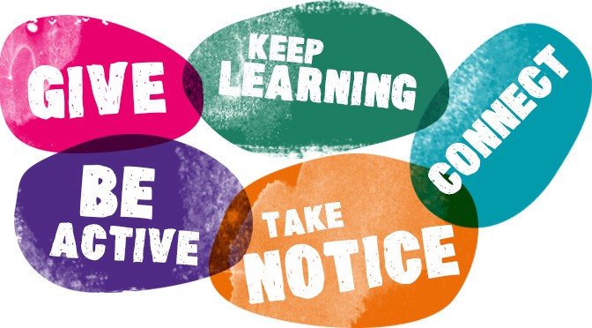
5 ways to wellbeing
This Photo by Unknown Author is licensed under CC BY-SA-NC

Sometimes life can feel challenging and stressful. We have so much going on in our minds we feel unsettled, anxious and a little unhappy.

Five ways to wellbeing are simple things we can all do to enjoy life and be kinder to ourselves, so that our minds and bodies are healthy.

The five ways to wellbeing are:

- Connect with others: listen to, speak to and connect with family and friends, this could be in person, over the phone or using social media

- Keep learning: try something new, learn a new skill, read a new book, be creative, surprise yourself

- Be Active: move your body and your mood! Do what you can, enjoy what you do and get moving, walking, running, playing, dancing….

- Take notice: be curious, ask questions, watch, think and appreciate what is around you and remember the simple things that make you happy

- Give: your time, your words, your presence and do something nice for someone else a friend, family member or someone you do not know by supporting a charity in some way

If you would like to find out more about the 5 ways to wellbeing look at:

- What do the Five ways to wellbeing mean? YouTube clip from Rochdale Borough Council:
https://www.youtube.com/watch?v=yF7Ou43Vj6c

- Mind
https://www.mind.org.uk/workplace/mental-health-at-work/taking-care-of-yourself/five-ways-to-wellbeing/

Putting the fives ways to wellbeing into action.

Try to remember the five ways to wellbeing each week. It is important to keep a balance and do a little bit of everything, this balance helps your wellbeing.
You can record what you have done, with writing or pictures…you can use these circles, your own paper or make a wellbeing calendar? Whatever suits you 😊

Keep learning
Connect with others

Be Active

Take notice
Give to others

Try and find your balance!

