Mindfulness Menu
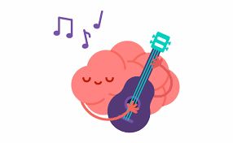


What is ‘mindfulness’?

Mindfulness is the ability to know what’s happening in your head at any given moment without getting carried away by it. Mindfulness activities help us to:
- pay attention to the feelings we have
- process those feelings
- respond to the feelings in a controlled way
Why do it?

Mindfulness has many benefits including reducing stress, helping us to pay attention, feel happier, learn more and be more patient. By don’t just take or word for it, listen to what other young adults have to say about mindfulness:

https://www.youtube.com/watch?time_continue=128&v=kk7IBwuhXWM&feature=emb_logo
Inspired?
Try some of the activities from the Mindfulness Menu below:
- 3-Minute    Music | Mindfully listening to a music track is a quick and effective stress reliever and a great way to practice being completely in the moment.  Choose a song to listen to – instead of just paying attention to the words, ask yourself:  What instruments do you hear? Is the song loud or soft, fast or slow?  What emotions does the song create in you?  Where in your body do you feel them? Can you feel the beat of the music in your body?
  - Build something! | According to a recent article from the UK, Lego has become a hugely popular mindfulness activity amongst young adults. Building with blocks or models allows your brain to ‘switch off’ and is very therapeutic, so get building!  https://www.telegraph.co.uk/news/2020/01/04/millennials-finding-mindfulness-lego/
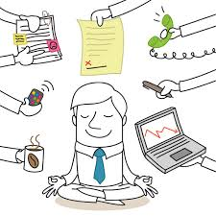  - Tech Detox | Too much time on devices can contribute to our stress; emails, news, notifications and social media can aggravate our worries and can distract us from our self-care. Taking a 30 minute break from ALL devices, including iPod/phones/TV will give you time to reconnect with yourself.
- Notice the Good   | Try and notice 3 things that are good, or even OK right now – it could be a kind action from someone, the sun shining, hearing from a friend.  You could write them down in a journal, put them in a ‘good things’ jar, talk with others about them or just think about them privately.
- The power of a poem…   | Reading poetry can be a helpful way to explore our emotions and experiences. Two poems which encourage mindfulness are:  - “The Guest House” by Rumi: Read the poem and think about what it would be like to welcome each emotion. Have you ever had emotions that felt like unwelcome visitors? Have you ever had difficult experiences that you ultimately learned something from? What things do you do to avoid feeling your emotions? What happens when you avoid them? Can you try to welcome even your unpleasant emotions?  - “Autobiography in Five Chapters” by Portia Nelson: What holes do you often fall into? Why is it so easy to make the same mistakes over and over? What new streets do you think you could walk down? What changes could you make that will help you better take care of yourself?
  6.Spidey-Senses | A quick and easy mindfulness exercise you can do anywhere, any time. Take a few minutes to stop and engage your “Spidey Senses,” the skill Spiderman uses to keep tabs on world around him.  Focus on each of your senses in turn: what you can see, smell, hear, taste and touch? Tuning into what we observe is a great skill, also for non super-humans!
  - App it! | Sometimes tech can help us with our mindfulness! Try this FREE app to help you to learn mindfulness and meditation practices:  Stop, Breathe, and Think.  This app opens with a short "interview" where you will select several words to describe how you are feeling, and then the app recommends guided meditations for your current state.
- Colour, Craft, Create,Cook!       | Any creative activity is a mindful activity! Steal your little siblings’ crayons, get out your sketch book, bake, knit or even head outside and make some ‘mandala’ art with natural materials.  Take time to do the crafty things you never get to do now you’re all grown up...
- The Worry Washing Machine!  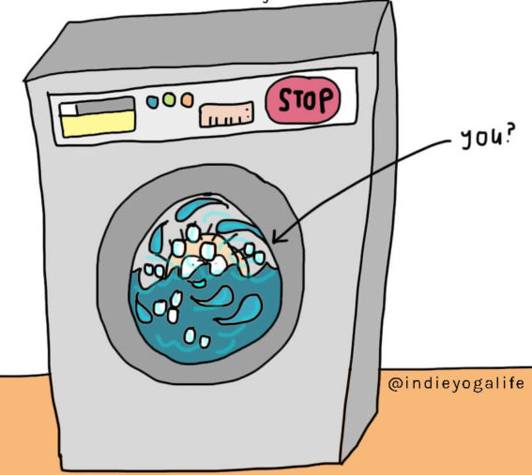 | Can’t stop yourself from worrying? Do your worries go round and round in your head like an overactive spin cycle?  Follow the steps in this funny but helpful guide to getting yourself out of that worry washing machine..  https://chedyer.com/how-to-stop-worrying-and-negative-thoughts-in-4-simple-steps/
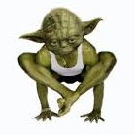  - Yoda | It’s yoga, not yoda! Even so, yoga can give the same ‘Zen vibe’ as our calm-as-a-cucumber Star Wars pal. There are many forms of yoga and not all of involve bending yourself into strange poses. It is, however, great for relieving your body of tension, stretching out your muscles and resting your mind. Got a spare 20 minutes? Give it a go:  https://yogawithadriene.com/yoga-for-teens/

Have a happy time being mindful!

